Nicholas Jurgens

1424898

TIM 105 Final

**Problem 1: Planning**

1. **Define the Problem**
   1. Make a list of the necessary activities/tasks, and draw the design (activity) structure matrix showing the task dependencies.
   2. Use GANTT charts to develop a schedule for completing the exam on time with high quality.
   3. Keep track of your progress and document when each task is completed.
2. **Create a Plan**
   1. **Step 1:** Make a list of the necessary activities/tasks
   2. **Step 2:** Draw the design (activity) structure matrix showing the task dependencies
   3. **Step 3:** Create a GANTT chart for a schedule for completing the exam
   4. **Step 4:** Keep track of the progress, documenting when each task is complete
3. **Execute**
   1. **Step 1:** List of activities/tasks

|  |  |
| --- | --- |
| **Activities/Tasks** | **Description** |
| Task A | Project Planning |
| Task B | Product Development |
| Task C | Financial Modeling |
| Task D | Information Technology |
| Task E | Conclusion |

* The above chart shows the tasks that I need to complete to complete the exam.
  1. **Step 2:** Activity Matrix

**Notation:**

X => “depends on”

BXA => subtask B depends on sub-task A

|  |  |  |  |  |  |
| --- | --- | --- | --- | --- | --- |
|  | **A** | **B** | **C** | **D** | **E** |
| **A** | **A** |  |  |  |  |
| **B** | X | **B** |  |  |  |
| **C** | X |  | **C** |  |  |
| **D** | X |  |  | **D** |  |
| **E** | X | X | X | X | **E** |

* The above activity matrix shows that tasks B-E are all dependent on A. This means that we must start with task A. Tasks B through D can then be done in any order since they’re independent of each other. Lastly E is dependent on all the previous tasks so it must be done last.
  1. **Step 3:** GANTT chart
* The above GANTT chart shows schedule for completing the tasks. Task A and B will be started on the first day. The rest of the problem will be started 2 days from start and finished on the same day.
  1. **Step 4:** Updates to schedule:

1. **Check Your Work**
   1. I believe that my plan is accurate and that I will be able to finish the final on time. I scheduled the tasks according to everything that I need to work on.
2. **Learn and Generalize**
   1. I learned that creating a project plan can help with meeting deadlines as well as overall project organization. My project plan was set up to have me finish the final by the end of the weekend s I could focus on my other finals as well.

**Problem 2: Product Development for a Virtual Reality Entertainment System**

1. **Define the Problem**
   1. Provide a written statement of your structured process for generating a feasible design concept for further development. **(This is the create a plan)**
   2. Dissect the video game console, the Oculus Rift, and the Microsoft Kinect.
   3. Implement your structured process and create a feasible concept for the VR entertainment system based on the functional requirements listed above. Provide a concise explanation of how the selected product concept works.
   4. Develop a product platform and product line strategy for the following three market segments
      1. Serious gamer
      2. Casual
      3. Professional
   5. Develop an FMEA of the product line designed or the “serious gamer” user. From the FMEA analysis identify the three most critical failure modes.
2. **Create a Plan**
   1. **Step 1:** Dissect the following products: Video game console, Oculus Rift, Microsoft Kinect
      1. **Step 1.1:** First understand how the specific product works.
      2. **Step 1.2:** Make a list of the important subsystems and components that are relevant to the FAST diagram.
      3. **Step 1.3:** Make a list of the main or primary function and the key sub-functions of the product
      4. **Step 1.4:** Write down the main or primary function for the system
      5. **Step 1.5:** Organize the FAST diagram with the “WHYs” to the right and the “HOWs” to the left
      6. **Step 1.6:** Creating a FAST diagram for a complex problem is a “Trial and Error” process.
   2. **Step 2:** Identify the main or primary function of the new product.
   3. **Step 3:** Establish customer needs and technical metrics/target specifications for the new product using the HOQ
      1. **Step 3.1:** Make a structured and prioritized list of the customer needs for the intended product based on market research
      2. **Step 3.2:** Make a list of technical metrics and assess the importance of each metric using a convenience
      3. **Step 3.3:** Correlate the customer needs and technical metrics using a convenience scale. The result is a correlation matrix
      4. **Step 3.4:** There are dependencies between the technical metrics
         1. a) correlate the technical metrics to each other using a convenience scale
         2. b) place the “half” of the matrix which is above the diagonal on top of the correlation
      5. **Step 3.5:** Benchmarking – assessing a set of related competing products from the viewpoint of the customer and from a technical viewpoint, using a convenience scale for customer benchmarking and engineering units of measurements for technical benchmarking
      6. **Step 3.6:** Setting targets for customer needs and technical metrics
   4. **Step 4:** Create an abstract functional representation for the intended new product, called the Functional Structure (FS)
   5. **Step 5:** 
      1. i) For each sub-function, generate several alternative solution principles (SPs) for realizing that sub-function
      2. ii) Organize the solution principles (SPs) in a morphological matrix (MM)
   6. **Step 6:** Generate 4-6 alternative concepts by suitability combining the solution principles in the MM. Each solution needs to be “sketched” and described
   7. **Step 7:** Identify an appropriate set of selection criteria to assess and compare the alternatives. Construct a utility function (UF) which will be used to compare and then select the “best” concept from these alternatives
   8. **Step 8:** Use the utility function to compare the alternatives (from step 6) and then select one (or two) feasible concepts for further development
   9. **Step 9:** Develop a product platform and product line strategy.
      1. **Step 9.1:** Define the underlying technology elements of the product platform: core (or defining) elements and supporting elements.
      2. **Step 9.2:** Segment market (for the product) based on your competitive strategy and market strategy; prioritize the target markets segments for the product.
      3. **Step 9.3:** Establish product lines to address (meet the demands of) the different market segments.
      4. **Step 9.4:** For each product line create the necessary project plan to introduce the product lines to the corresponding market segments in a time-phased manner
      5. **Step 9.5:** Introduce product lines in a time-phased manner to “cover” (reach) all the desired targets.
   10. **Step 10:** Develop an FMEA of the product line designed for the “serious gamer” user. Identify the three most critical failure modes.
       1. **Step 10.1:** Create a FAST diagram for the product to
          1. Identify the key subsystems and components of the product
          2. Understand the key sub-functions of these sub-systems
       2. **Step 10.2:** For each sub-system identify potential failure modes, and characterize these failure modes using a Risk Priority Number. Calculate the RPN. Construct a table for this.
       3. **Step 10.3:** List the three most critical failure modes.
3. **Execute**
   1. **Step 1:** Dissect the following products: Video game console, Oculus Rift, Microsoft Kinect

**Video Game Console**

* + 1. **Step 1.1:** 
       1. The N64 is a RISC processor which means that the instructions and computations performed by the processor are simpler and fewer.
       2. The graphics and audio processors are combined into a single application specific integrated circuit, or ASIC.
       3. The Console runs games through the following steps.
          1. You turn the power on.
          2. The console loads portions of the operating system from ROM into RAM.
          3. The game initialization sequence is loaded into RAM.
          4. You interact with the game via the **controller**.
          5. As each specific part of the game is requested, the application code, video, audio and hardware-render geometry are loaded into RAM.
          6. The CPU coordinates everything. It receives the input from the controller, pulls the data from RAM and directs the graphics and audio processing.
          7. You are finally beaten by the game and turn it off.
       4. The controller is the primary user interface for the N64
    2. **Step 1.2:**
       1. System -> N64
       2. Subsystems
          1. CPU
          2. Co-Processor
          3. RDRAM
          4. Controller
          5. Cartridge Slot
    3. **Step 1.3:**
       1. System -> N64
       2. Sub-function Sub-System

Executes instructions CPU

Interfaces to CPU Co-Processor

Stores data RDRAM

Interface for N64 Controller

Stores game cartridges Cartridge Slot

* + 1. **Step 1.4:**
       1. The primary function of the N64 is interactive video gameplay and display.
    2. **Step 1.5:**
       1. HOWs WHYs

Executes Instructions CPU

Handles audio/graphics processing Co-Processor

Stores data RDRAM

Input for Console Controller

Stores game cartridges Cartridge Slot

* + 1. **Step 6:**

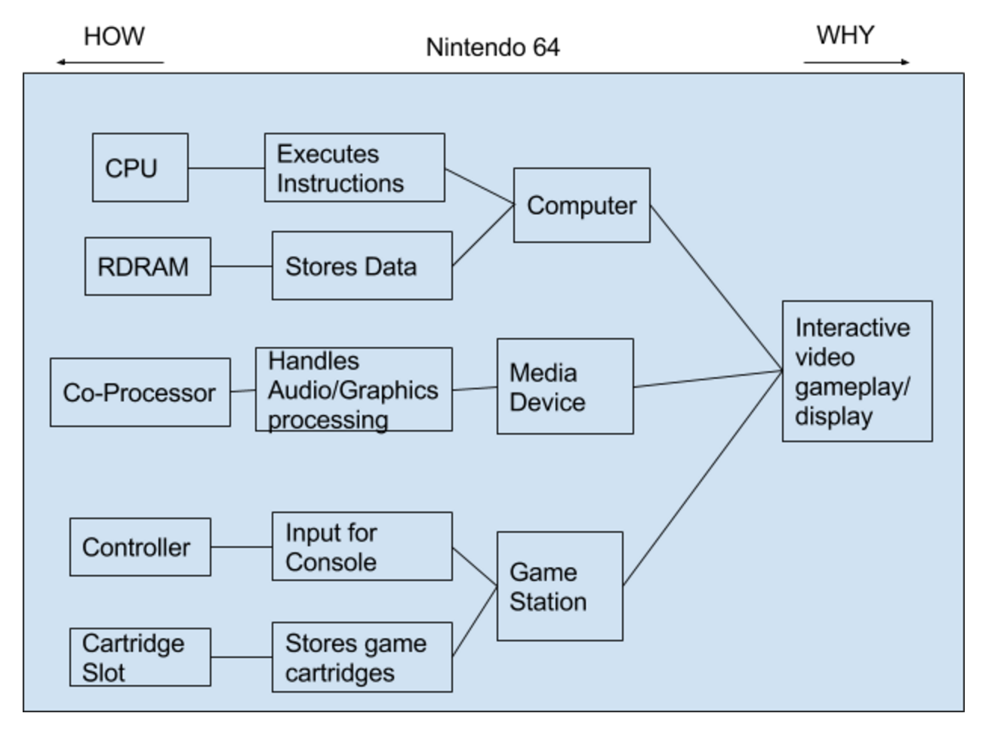

* The above FAST diagram shows **HOW** the N64 works and **WHY** it works.

**Virtual Reality Headset (The Oculus Rift)**

* + 1. **Step 1.1:**
       1. The device is a lightweight virtual reality headset that blocks your view of your surroundings and fully immerses you in a virtual world. The Rift lets you step into a game, look around in any direction and see the game environment all around you rather than on a flat screen surrounded by your living room decor. And you see it in 3D.
       2. The kit also comes with a control box that's permanently attached to the headset via a 6-foot (1.8-meter) cable, a removable over-the-head strap for added comfort and stability, three pairs of vision lenses of different focal lengths, an HDMI cable, a USB cable, a DVI cable, an HDMI to DVI adapter and a 5-Volt switching US-standard power supply along with international power adapters.
       3. The control box is used to hook the headset up to your computer and perform basic control functions.
       4. A blue LED on top shows you whether the device is on or off.
       5. The device has a custom-built motion and orientation sensor unit with a sampling rate of up to 1000 Hz. The sensor unit includes a gyroscope, an accelerometer and a magnetometer, along with an ARM Cortex-M3 microcontroller. The data from all three sensors is combined through a process called sensor fusion to enable fast and accurate tracking of your head orientation and synchronization with what you are viewing. This allows you to turn your head in any direction and look around the virtual environment in real-time, but it doesn't allow for positional tracking.
    2. **Step 1.2:**
       1. System -> Oculus Rift
       2. Subsystems
          1. Control Box
          2. Over-the-head strap
          3. Vision lenses
          4. Video Ports
          5. Power supply
          6. LCD Display screen
          7. Motion sensor unit
    3. **Step 1.3:**

|  |  |
| --- | --- |
| **System:** Oculus Rift | |
| **Sub-system** | **Sub-function** |
| Control Box | Allows video output. |
| Over-the-head strap | Holds the device on user’s head |
| Vision lenses | Sharpens the user’s vision of the screen. |
| Video Ports | Allows for connection to other devices |
| Power Supply | Powers the VR headset |
| LCD Display Screen | Displays image of the game |
| Motion sensor unit | Tracks head orientation |

* + 1. **Step 1.4:**
       1. The primary function of the Oculus Rift is to immerse the user in a virtual environment.
    2. **Step 1.5:**

|  |  |
| --- | --- |
| **HOWs** | **WHYs** |
| Control Box | Allows video output. |
| Over-the-head strap | Holds the device on user’s head |
| Vision lenses | Sharpens the user’s vision of the screen. |
| Video Ports | Allows for connection to other devices |
| Power Supply | Powers the VR headset |
| LCD Display Screen | Displays image of the game |
| Motion sensor unit | Tracks head orientation |

* + 1. **Step 1.6:**

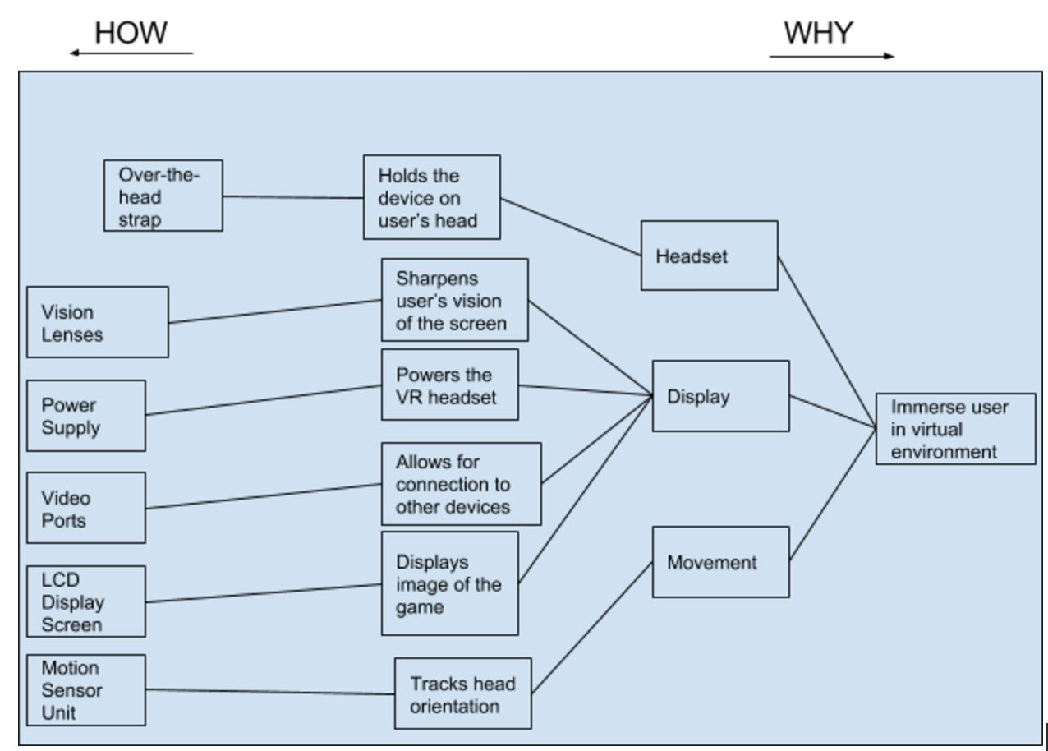

* The above FAST diagram shows **HOW** the Oculus Rift works and **WHY** it works.

**Video-game motion-tracking sensor (Microsoft Kinect)**

* + 1. **Step 1.1:**
       1. The Kinect uses a video camera to aid in facial recognition and other detection features by detecting three color components: red, green, and blue.
       2. It has a depth sensor that works to “see” the room in 3-D regardless of the lighting conditions
       3. It has a multi-array microphone that can isolate the voices of the players from the noise in the room.
       4. When you first start up Kinect, it reads the layout of your room and configures the play space you'll be moving in. Then, Kinect detects and tracks 48 points on each player's body, mapping them to a digital reproduction of that player's body shape and skeletal structure, including facial details
       5. The Kinect software can distinguish players and their movements even if they’re partially hidden. It extrapolates what the rest of your body is doing as long as it can detect some parts of it.
    2. **Step 1.2:**
       1. System -> Microsoft Kinect
       2. Sub-systems
          1. Color VGA video camera
          2. Depth Sensor
          3. Multi-array microphone
    3. **Step 1.3:**

|  |  |
| --- | --- |
| **System:** Microsoft Kinect | |
| **Sub-system** | **Sub-function** |
| Color VGA video camera | Detects three color components |
| Depth Sensor | Sees the room in 3-D |
| Multi-array microphone | Isolates voices from outside sound |

* + 1. **Step 1.4:**
       1. The primary function of the Microsoft Kinect is to provide an interactive video game experience through motion detection without the need for physical controllers.
    2. **Step 1.5:**

|  |  |
| --- | --- |
| **HOWs** | **WHYs** |
| Color VGA video camera | Detects three color components |
| Depth Sensor | Sees the room in 3-D |
| Multi-array microphone | Isolates voices from outside sound |

* + 1. **Step 1.6:**

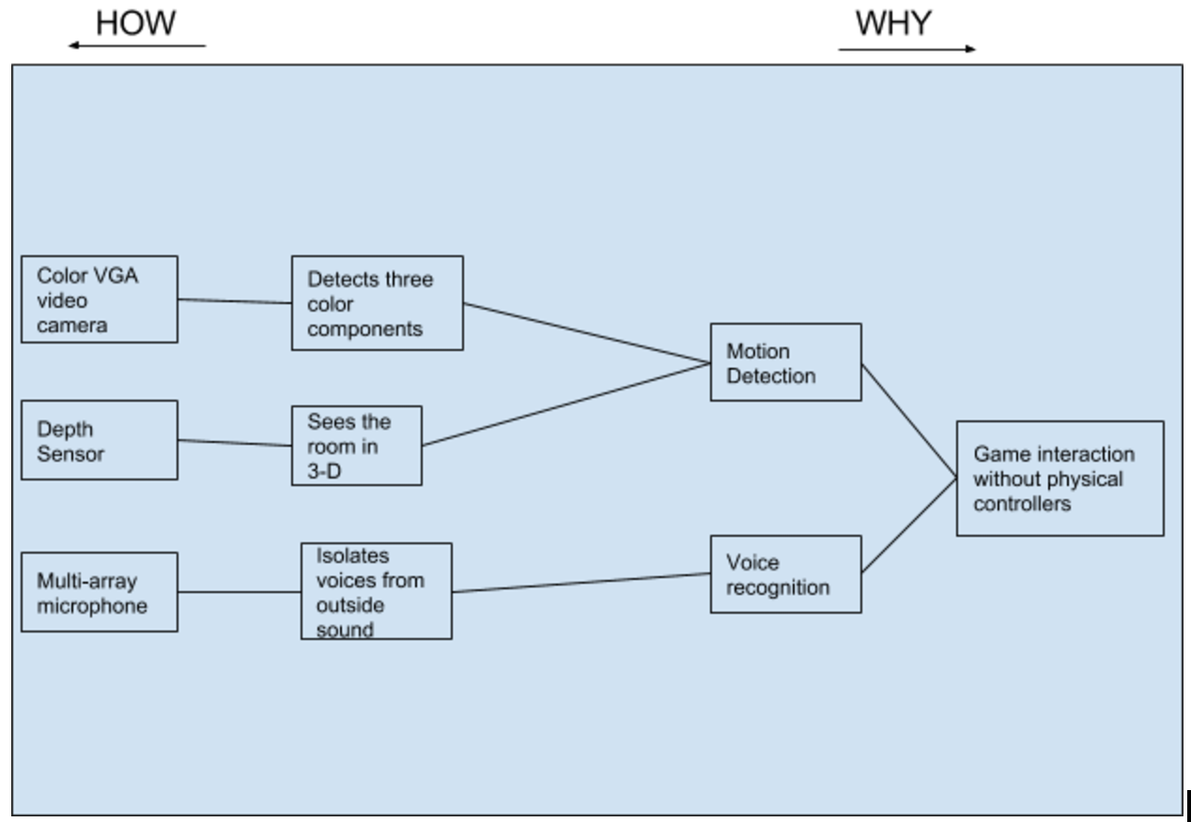

* The above FAST diagram shows **HOW** the Microsoft Kinect works and **WHY** it works.
  1. **Step 2:** 
     1. The primary function for the new virtual reality (VR) entertainment system is to provide an immersive virtual reality experience where the user can move around and interact with a virtual world.
  2. **Step 3:** 
     1. **Step 3.1:**

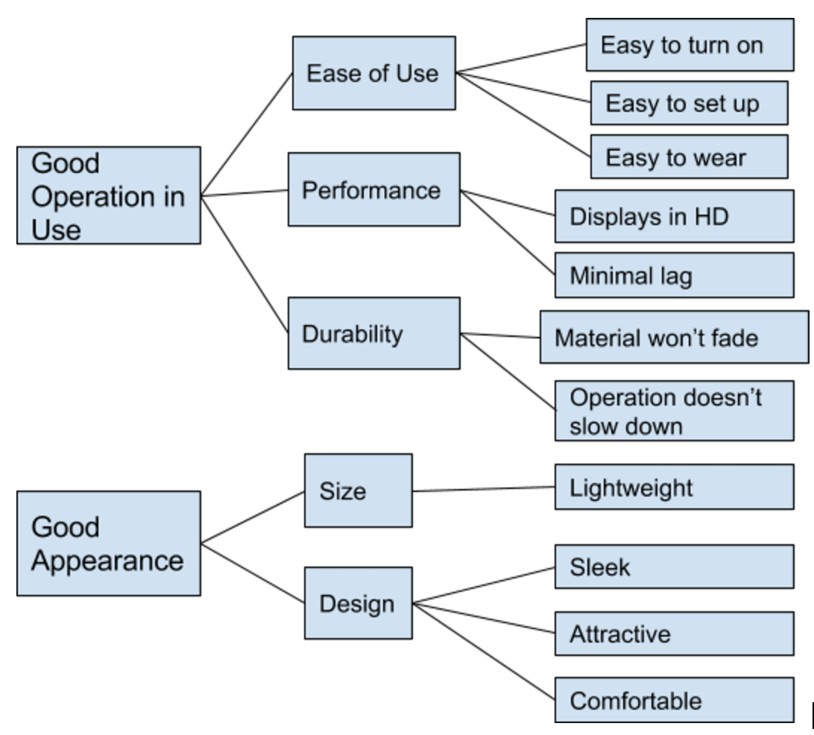

|  |  |
| --- | --- |
| **Customer Needs** | **Importance** |
| Cost | 5 |
| Ease of Use | 6 |
| Video Quality | 8 |
| Games | 10 |
| Durability | 6 |
| Sound Quality | 8 |

* The above table shows the Customer needs for virtual reality entertainment systems and how important it is to them
  + I ranked cost at 5 because with a new device that has never been on the market before, people will want to be the first ones to use it.
  + I ranked Ease of Use at 6 because I believed that some of the people buying the gaming console would like it to be easy to use. More so since it is a new device in the market.
  + I ranked video quality at 8 as most of the customers wanted to have high quality graphics.
  + I ranked games at 10 because people buy consoles to play games.
  + I ranked durability at 6 because if the system breaks down too easily people won’t bother buying one.
  + I ranked sound quality at 8 because people want something that sounds and looks great when they played. Sound is an important factor when trying to become immersed in a game.
    1. **Step 3.2:**

|  |  |  |
| --- | --- | --- |
| **Technical Metrics** | **Importance** | **Measurements** |
| Video Quality | 8 | Pixels |
| Sound Quality | 8 | kHz |
| Storage | 5 | GB |
| CPU | 10 | GHz |
| Operating System | 8 | Type |
| Game Slot | 8 | Type |
| Microphone | 5 | Yes/No |
| Depth Sensor | 7 | Type |
| Motion Sensing Unit | 10 | Type |

* The above table shows the Technical Metrics for the Gaming Console and how important it is.
  + I ranked video quality at 8 because in order to feel immersed in the game the video quality must be good.
  + I ranked sound quality at 8 because in order to be fully immersed the system must have convincing sound effects.
  + I ranked storage at 5 because the VR needs to be able to run high memory games.
  + I ranked the CPU at 10 because the better the CPU the better the whole device will function.
  + I ranked the operating system at 8 because the type of OS affects what the system can do and how it works.
  + I ranked the game slot at 8 because it is important to have the current game slot that is compatible with most games.
  + I ranked microphone at 5 because it’s not necessary for the system operation.
  + I ranked the depth sensor at 7 because it is important for the user experience to be uninterrupted when in the virtual environment.
  + I ranked the motion sensing unit at 10 because it is what drives this product. The better the motion sensing technology the more fluid the movement and gameplay will be.
    1. **Step 3.3:** Customer Needs/Technical Metrics Convenience Scale

Strong Correlation: **S**

Moderate Correlation: **M**

Weak Correlation: **W**

|  |  |  |  |  |  |  |  |  |
| --- | --- | --- | --- | --- | --- | --- | --- | --- |
| Video Quality | Sound Quality | Storage | CPU | Operating System | Game Slot | Microphone | Depth Sensor | Motion Sensing Unit |
| 8 | 8 | 5 | 10 | 8 | 8 | 5 | 7 | 10 |
| Cost | 5 | **S** | **S** | **M** | **S** | **M** | **W** | **M** | **S** | **S** |
| Ease of Use | 6 |  |  |  |  | **S** | **S** | **W** |  | **M** |
| Video Quality | 8 | **S** |  | **M** | **W** | **W** |  |  |  |  |
| Games | 10 |  |  | **M** | **M** | **M** | **S** |  | **M** | **M** |
| Durability | 6 |  |  |  | **M** |  | **M** | **M** | **S** | **M** |
| Sound Quality | 8 |  | **S** | **M** | **M** |  |  | **M** |  |  |

* + 1. **Step 3.4:**
       1. **Technical Metrics Convenience Scale**

Strong Positive Correlation: **+**

Strong Negative Correlation: **-**

|  |  |  |  |  |  |  |  |  |
| --- | --- | --- | --- | --- | --- | --- | --- | --- |
| Video Quality | Sound Quality | Storage | CPU | Operating System | Game Slot | Microphone | Depth Sensor | Motion Sensing Unit |
| 8 | 8 | 5 | 10 | 8 | 8 | 5 | 7 | 10 |
| Video Quality | 8 |  |  | **-** | **+** | **+** |  |  |  | **+** |
| Sound Quality | 8 |  |  | **-** | **+** |  |  | **+** |  |  |
| Storage | 5 |  |  |  | **+** | **+** |  |  |  |  |
| CPU | 10 |  |  |  |  | **+** |  |  | **+** | **+** |
| Operating System | 8 |  |  |  |  |  |  |  | **+** | **+** |
| Game Slot | 8 |  |  |  |  |  |  |  |  |  |
| Microphone | 5 |  |  |  |  |  |  |  |  |  |
| Depth Sensor | 7 |  |  |  |  |  |  |  |  | **+** |
| Motion Sensing Unit | 10 |  |  |  |  |  |  |  |  |  |

* + - 1. **Place half of the above matrix on top of the correlation**

|  |  |  |  |  |  |  |  |
| --- | --- | --- | --- | --- | --- | --- | --- |
|  | **-** | **+** | **+** |  |  |  | **+** |
|  | **-** | **+** |  |  | **+** |  |  |
|  |  | **+** | **+** |  |  |  |  |
|  |  |  | **+** |  |  | **+** | **+** |
|  |  |  |  |  |  | **+** | **+** |
|  |  |  |  |  |  |  |  |
|  |  |  |  |  |  |  |  |
|  |  |  |  |  |  |  | **+** |

|  |  |  |  |  |  |  |  |  |
| --- | --- | --- | --- | --- | --- | --- | --- | --- |
| Video Quality | Sound Quality | Storage | CPU | Operating System | Game Slot | Microphone | Depth Sensor | Motion Sensing Unit |
| 8 | 8 | 5 | 10 | 8 | 8 | 5 | 7 | 10 |
| Cost | 5 | **S** | **S** | **M** | **S** | **M** | **W** | **M** | **S** | **S** |
| Ease of Use | 6 |  |  |  |  | **S** | **S** | **W** |  | **M** |
| Video Quality | 8 | **S** |  | **M** | **W** | **W** |  |  |  |  |
| Games | 10 |  |  | **M** | **M** | **M** | **S** |  | **M** | **M** |
| Durability | 6 |  |  |  | **M** |  | **M** | **M** | **S** | **M** |
| Sound Quality | 8 |  | **S** | **M** | **M** |  |  | **M** |  |  |

* + 1. **Step 3.5:**
       1. **See attached paper**
    2. **Step 3.6:**

|  |  |
| --- | --- |
| **Target Consumer Specs** | **Importance** |
| Cost | 6 |
| Ease of Use | 8 |
| Video Quality | 9 |
| Games | 8 |
| Durability | 7 |
| Sound Quality | 9 |

* **Target Consumer Spec Reasoning**
  + I ranked the cost at 6 because I believe that the VR market is extremely popular right now and people just want to try the new products.
  + I ranked the ease of use at 8 because I believe that it is essential for the VR industry. It is a new type of tech that people are not familiar with. The easier it is to introduce; the more likely people will be to buy it.
  + I ranked the video quality at 9 because when people look at VR and gaming in general, graphics are one of the most important specifications to the consumer. They want their games to look realistic.
  + I ranked games at 8 because people buying gaming consoles to play games. However, this VR tech can be used for professional use as well so it’s not ranked at 10.
  + I ranked the durability at 7 because people want to buy a product that lasts.
  + I ranked sound quality at 9 because when using VR sound can help players feel like they’re in the game. This is the main reason they’re buying the tech.

|  |  |  |
| --- | --- | --- |
| **Target Technical Metrics** |  | **Measurements** |
| Video Quality | 1920x1080 | Pixels |
| Sound Quality | 3D Audio | kHz |
| Storage | 500 | GB |
| CPU | i7 | GHz |
| Operating System | Multi | Type |
| Game Slot | Plug-in/disc | Type |
| Microphone | Yes | Yes/No |
| Depth Sensor | Yes | Type |
| Motion Sensing Unit | Constellation Tracking | Type |

* **Target technical specifications reasoning:**
  + My target for the video quality is 1920x1080 because it would match one of the toughest competitors, Sony. Also video quality is important when making players believe they’re in the game.
  + My target for sound quality is 3D audio so the players can hear sounds from every direction.
  + My target for storage is 500GB which is the current standard.
  + My target for CPU is i7 because I want to push the limit and outperform both Sony and Oculus.
  + My target for the Operating System is to have it supported by multiple. This way it can run on more devices.
  + My target for the game slot is to be able to plug in and play as well as have it’s own disc slot.
  + My target for the microphone is to have one installed to allow for easy communication between players as well as provide the hands-free experience when interacting with the system.
  + My target for the depth sensor is to have one installed in order to allow user to play the game uninterrupted. This plays into the whole VR experience.
  + My target for the motion sensing unit is to have constellation tracking because it seems to provide the most accurate form of movement tracking for VR.
  1. **Step 4:**

**Functional Structure for VR headset**

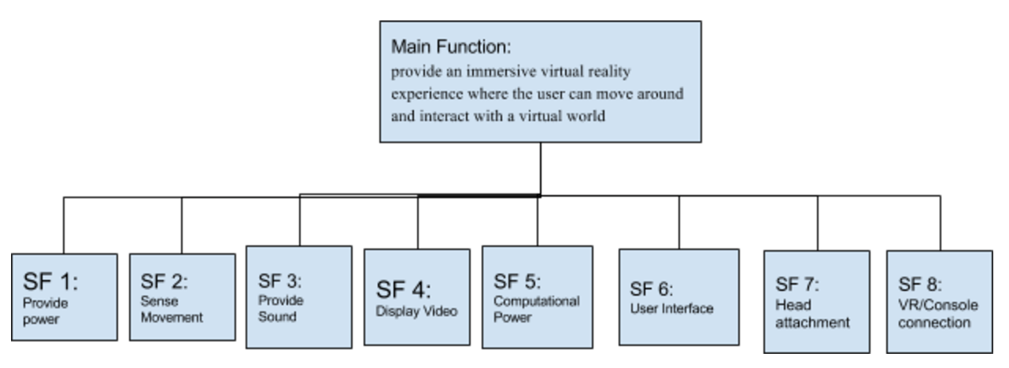

* 1. **Step 5:**
     1. Solution principles of Sub-Functions
        1. SF1: electrical, battery, solar
        2. SF2: Eye Tracking, Constellation Tracking, Lighthouse Laser
        3. SF3: 3D, HDMI, AUX
        4. SF4: OLED, LED, LCD
        5. SF5: CPU, APU, processor
        6. SF6: controller, voice recognition, touch
        7. SF7: Strap, helmet, suction
        8. SF8: tethered, wireless, single unit
     2. Morphological Matrix

|  |  |  |  |
| --- | --- | --- | --- |
| **Solution Principles (SP)**  **Sub. Functions (SF)** | **SP 1** | **SP 2** | **SP 3** |
| **SF 1:**  **Provide Power** | Electrical | Battery | Solar |
| **SF 2:**  **Sense Movement** | Eye Tracking | Constellation Tracking | Lighthouse Laser |
| **SF 3:**  **Provide Sound** | 3D | HDMI | AUX |
| **SF 4:**  **Display Video** | OLED | LED | LCD |
| **SF 5:**  **Computational Power** | CPU | APU | Processor |
| **SF 6:**  **User Interface** | Controller | Voice recognition | Touch |
| **SF 7:**  **Head Attachment** | Strap | Helmet | Suction |
| **SF 8:**  **VR/Console Connectivity** | Tethered | Wireless | Single Unit |

* The above morphological matrix has three SP’s for each SF. For SF1 we have electrical, battery and solar. These seem to be the most popular forms of supplying energy. For SF2 we have eye tracking, constellation tracking, and lighthouse laser tracking because they are the most popular forms of motion tracking for VR. For SF3 we have 3D, HDMI, and AUX. We believe these three options will provide the best audio quality. For SF4 we have OLED, LED, and LCD because they are the main forms of display. For SF5 we have CPU, APU, and processor. For SF6 we have controller, voice recognition, and touch. We believe the last two would provide the best VR experience. For SF7 we have strap, helmet, and suction. The best option here would be the helmet or strap for comfortability and immersion. Lastly we have SF8 which has tethered, wireless, or single unit. The single unit would be hard to produce as the console may be to heavy.
  1. **Step 6:** Alternative Concepts

Each color line is a separate design concept.

|  |  |  |  |
| --- | --- | --- | --- |
| **Solution Principles (SP)**  **Sub. Functions (SF)** | **SP 1** | **SP 2** | **SP 3** |
| **SF 1:**  **Provide Power** | Electrical | Battery | Solar |
| **SF 2:**  **Sense Movement** | Eye Tracking | Constellation Tracking | Lighthouse Laser |
| **SF 3:**  **Provide Sound** | 3D | HDMI | AUX |
| **SF 4:**  **Display Video** | OLED | LED | LCD |
| **SF 5:**  **Computational Power** | CPU | APU | Processor |
| **SF 6:**  **User Interface** | Controller | Voice recognition | Touch |
| **SF 7:**  **Head Attachment** | Strap | Helmet | Suction |
| **SF 8:**  **VR/Console Connectivity** | Tethered | Wireless | Single Unit |

* **Alternative Concept 1:**
  + **SF1:** Uses electrical energy to power the console and headset
  + **SF2:** Uses light laser technology to sense movement
  + **SF3:** Uses 3D audio to provide sound from all directions
  + **SF4:** Uses OLED to display video image
  + **SF5:** Uses CPU to execute tasks
  + **SF6:** Users use touch to interact with the system
  + **SF7:** User wears the device as a helmet
  + **SF8:** Uses tethered connection to link console and VR headset

|  |  |  |  |
| --- | --- | --- | --- |
| **Solution Principles (SP)**  **Sub. Functions (SF)** | **SP 1** | **SP 2** | **SP 3** |
| **SF 1:**  **Provide Power** | Electrical | Battery | Solar |
| **SF 2:**  **Sense Movement** | Eye Tracking | Constellation Tracking | Lighthouse Laser |
| **SF 3:**  **Provide Sound** | 3D | HDMI | AUX |
| **SF 4:**  **Display Video** | OLED | LED | LCD |
| **SF 5:**  **Computational Power** | CPU | APU | Processor |
| **SF 6:**  **User Interface** | Controller | Voice recognition | Touch |
| **SF 7:**  **Head Attachment** | Strap | Helmet | Suction |
| **SF 8:**  **VR/Console Connectivity** | Tethered | Wireless | Single Unit |

* **Alternative Concept 2:**
  + **SF1:** Uses battery energy to power the console and headset
  + **SF2:** Uses eye tracking technology to sense movement
  + **SF3:** Uses HDMI audio to provide sound from all directions
  + **SF4:** Uses LED to display video image
  + **SF5:** Uses APU to execute tasks
  + **SF6:** Users controller to interact with the system
  + **SF7:** User wears the device using a strap
  + **SF8:** Uses wireless connection to link console and VR headset

|  |  |  |  |
| --- | --- | --- | --- |
| **Solution Principles (SP)**  **Sub. Functions (SF)** | **SP 1** | **SP 2** | **SP 3** |
| **SF 1:**  **Provide Power** | Electrical | Battery | Solar |
| **SF 2:**  **Sense Movement** | Eye Tracking | Constellation Tracking | Lighthouse Laser |
| **SF 3:**  **Provide Sound** | 3D | HDMI | AUX |
| **SF 4:**  **Display Video** | OLED | LED | LCD |
| **SF 5:**  **Computational Power** | CPU | APU | Processor |
| **SF 6:**  **User Interface** | Controller | Voice recognition | Touch |
| **SF 7:**  **Head Attachment** | Strap | Helmet | Suction |
| **SF 8:**  **VR/Console Connectivity** | Tethered | Wireless | Single Unit |

* **Alternative Concept 3:**
  + **SF1:** Uses electrical energy to power the console and headset
  + **SF2:** Uses constellation tracking technology to sense movement
  + **SF3:** Uses HDMI audio to provide sound from all directions
  + **SF4:** Uses OLED to display video image
  + **SF5:** Uses APU to execute tasks
  + **SF6:** Users use voice recognition to interact with the system
  + **SF7:** User wears the device using a strap
  + **SF8:** Uses tethered connection to link console and VR headset

|  |  |  |  |
| --- | --- | --- | --- |
| **Solution Principles (SP)**  **Sub. Functions (SF)** | **SP 1** | **SP 2** | **SP 3** |
| **SF 1:**  **Provide Power** | Electrical | Battery | Solar |
| **SF 2:**  **Sense Movement** | Eye Tracking | Constellation Tracking | Lighthouse Laser |
| **SF 3:**  **Provide Sound** | 3D | HDMI | AUX |
| **SF 4:**  **Display Video** | OLED | LED | LCD |
| **SF 5:**  **Computational Power** | CPU | APU | Processor |
| **SF 6:**  **User Interface** | Controller | Voice recognition | Touch |
| **SF 7:**  **Head Attachment** | Strap | Helmet | Suction |
| **SF 8:**  **VR/Console Connectivity** | Tethered | Wireless | Single Unit |

* **Alternative Concept 4:**
  + **SF1:** Uses solar energy to power the console and headset
  + **SF2:** Uses eye tracking technology to sense movement
  + **SF3:** Uses AUX audio to provide sound from all directions
  + **SF4:** Uses LCD to display video image
  + **SF5:** Uses a processor to execute tasks
  + **SF6:** Users use a controller to interact with the system
  + **SF7:** User wears the device using suction technology.
  + **SF8:** Console and VR built as one single unit
  1. **Step 7:** Selection Criteria and Utility Function
* **Selection Criteria:** The selection criteria can be found in step 3.1 of the House of Quality



* **Utility Function (UF):** Using the selection criteria above, construct a utility function which will be used to compare, and then select the “best” concept from these alternatives.

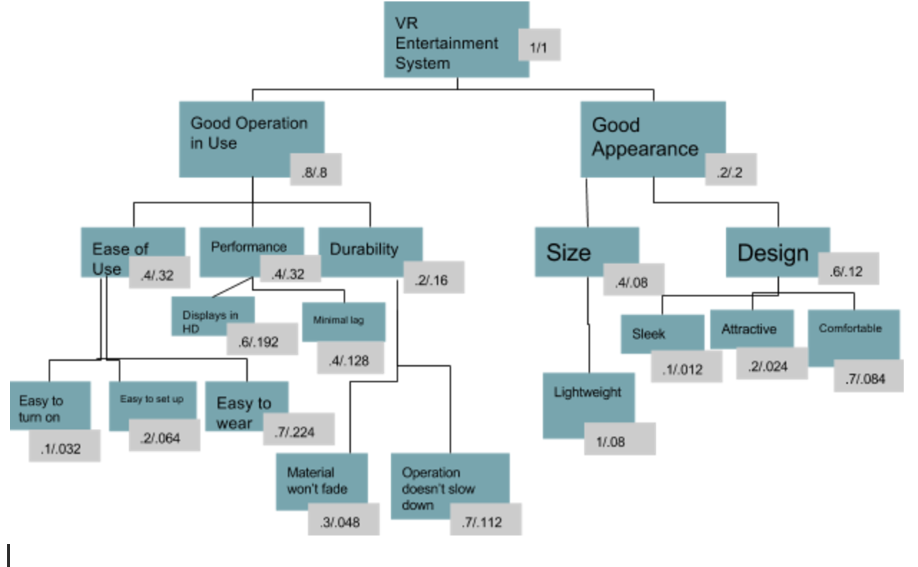

* **Selection Criteria**
  + **S1:** Easy to turn on
  + **S2:** Easy to set up
  + **S3:** Easy to wear
  + **S4:** Displays in HD
  + **S5:** Minimal Lag
  + **S6:** Material won’t fade
  + **S7:** Operation doesn’t slow down
  + **S8:** Lightweight
  + **S9:** Sleek
  + **S10:** Attractive
  + **S11:** Comfortable

This graph is part of the utility function Each of the four concepts is given a rating based on how effectively thy will perform their function (1 out of 5). The absolute weight values are taken from the UF above. We then multiply the absolute weight with the rating in order to get the utility. The last row has the sums of the utility for each concept.

|  |  |  |  |  |  |  |  |  |  |
| --- | --- | --- | --- | --- | --- | --- | --- | --- | --- |
| Selection Criteria | Absolute Weight | Concept 1 | | Concept 2 | | Concept 3 | | Concept 4 | |
| Rating | Utility | Rating | Utility | Rating | Utility | Rating | Utility |
| S1 | .032 | 5 | .16 | 4 | .128 | 5 | .16 | 4 | .128 |
| S2 | .064 | 4 | .256 | 4 | .256 | 4 | .256 | 3 | .192 |
| S3 | .224 | 5 | 1.12 | 3 | .672 | 3 | .672 | 2 | .448 |
| S4 | .192 | 5 | .96 | 4 | .768 | 5 | .96 | 4 | .768 |
| S5 | .128 | 5 | .64 | 4 | .512 | 5 | .64 | 2 | .256 |
| S6 | .048 | 5 | .24 | 4 | .192 | 5 | .24 | 4 | .192 |
| S7 | .112 | 4 | .448 | 4 | .448 | 4 | .448 | 3 | .336 |
| S8 | .08 | 3 | .24 | 4 | .32 | 3 | .24 | 2 | .16 |
| S9 | .012 | 4 | .048 | 3 | .036 | 3 | .036 | 2 | .024 |
| S10 | .024 | 5 | .12 | 3 | .072 | 4 | .096 | 2 | .048 |
| S11 | .084 | 5 | .42 | 4 | .336 | 3 | .252 | 1 | .084 |
| Sum | 1 |  | CU1=4.652 |  | CU2=3.74 |  | CU3=4 |  | CU4=2.636 |

* 1. **Step 8:** Ranking Design Concepts
     1. 1st: Concept 1 -> CU1 = 4.652
     2. 2nd: Concept 3 -> CU3 = 4
     3. 3rd: Concept 2 -> CU2 = 3.74
     4. 4th: Concept 4 -> CU4 = 2.636
  2. **Step 9:** Product Platform/Product Line Strategy
     1. **Step 9.1:** Core and Supporting Elements

|  |  |
| --- | --- |
| **Core Elements of VR Entertainment System** | **Supporting Elements** |
| Virtual Reality | In-game realistic touch |
| HD Graphics | OLED/HDMI Display |
| Motion Sensing | Lighthouse Laser Tracking |
| Surround Sound | 3D Audio |

* + 1. **Step 9.2:** Target market Segmentation

|  |  |
| --- | --- |
| **Market Segments** | **Importance (1-5) 5 is most important** |
| Serious Gamer | **5** |
| Casual | **4** |
| Professional | **3** |

* The market we want to target with the VR entertainment system is the Serious Game market. This is because the people most interested in this tech are the hardcore gamers who want the latest and greatest games. By starting with this market we are also simultaneously working with the casual players as well. We can secure the funds from initial releases because gamers are willing to purchase and test these new products. Once we have done this we can slowly work our way into the professional market as well. This allows us to provide companies with a more accurate and reliable system from the start.
  + 1. **Step 9.3:** Product Lines

|  |  |
| --- | --- |
| **Market Segments** | **Indoor Mobile Robot** |
| Serious Gamer |  |
| Casual |  |
| Professional |  |
| In-game realistic touch |
| OLED/HDMI Display |
| Lighthouse Laser Tracking |
| 3D Audio |

* + 1. **Step 9.4:** Project Plan

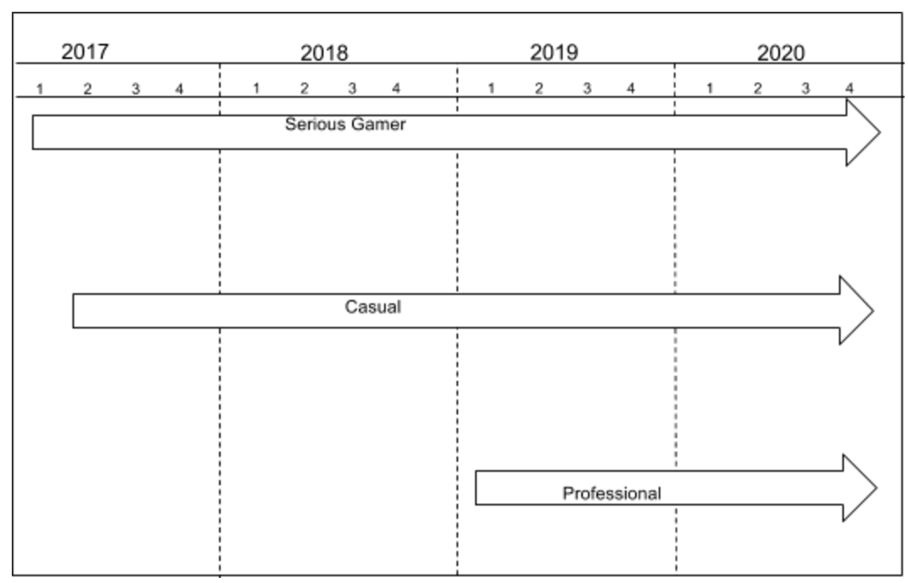

* In the functional map above, we have the proposed time-line to introduce the product line into each market segment. We would like to start with the serious gamers and casual gamers. This is because it is easy to work with both of them at the same time as many of the focused areas on the product overlap. Once we perfect the product and eliminate most bugs, we will introduce the VR entertainment system to the professional market towards the beginning of 2019.
  + 1. **Step 9.5:** Introduction of product lines in a time-phased manner to reach all desired market segments

|  |  |  |  |  |
| --- | --- | --- | --- | --- |
| **Segments** | | | | |
| Serious Gamer |  |  |  |  |
| Casual |  |  |  |  |
| Professional |  |  |  |  |
| Year | **2017** | **2018** | **2019** | **2020** |

* The above figure shows our goal of introducing our product lines into the target segments. The goal is to have all of the segment covered over the next four years.
  1. **Step 10:** FMEA of the product line for the serious gamer
     1. **Step 10.1:** FAST diagram of the VR entertainment system.

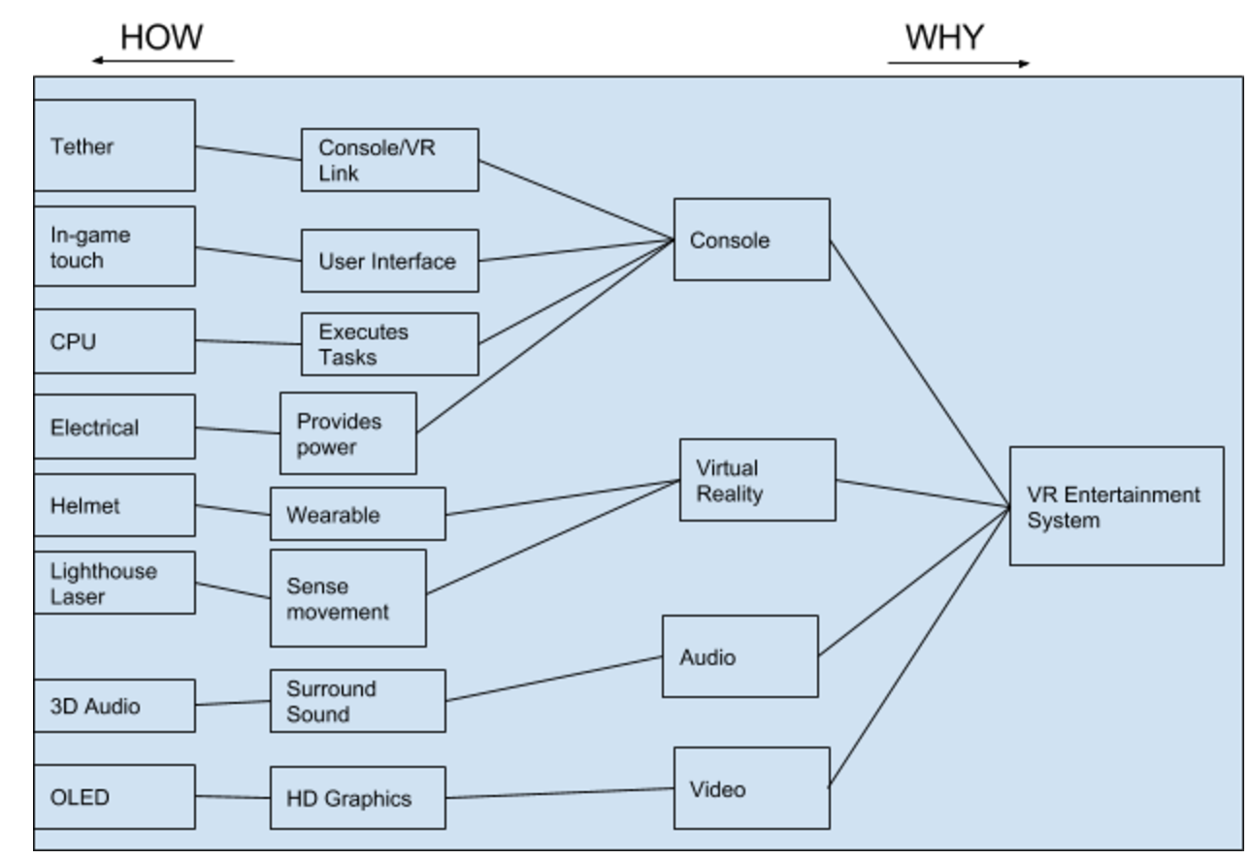

* The above FAST diagram shows how the VR entertainment system works.
  + 1. **Step 10.2:**

|  |  |  |  |  |  |  |
| --- | --- | --- | --- | --- | --- | --- |
| **Sub-system** | **Potential Failure Modes** | **Effects** | **S:** Severity (Scale of 1-8) | **F:** Frequency (Scale of 1-8) | **D:** Detection (Scale of 1-8) | **RPN**  **(S x F x D)** |
| Tether | Cable disconnects | Loss of control/visual | **8** | **1** | **1** | **8** |
| In-game touch | Incorrect calibration | Difficulty operating system | **5** | **4** | **1** | **20** |
| CPU | Faulty circuitry | Systems crashes | **8** | **1** | **7** | **56** |
| Helmet | Cracks | Overall system performance falls | **5** | **4** | **1** | **20** |
| Electrical | Faulty wiring | System loses power | **8** | **2** | **8** | **128** |
| Lighthouse laser | Inaccurate tracking | Loss of control in game | **6** | **5** | **4** | **120** |
| 3D Audio | Blown speakers | No audio | **7** | **4** | **1** | **28** |
| OLED | Pixel failure | Blacks spots on screen | **4** | **5** | **1** | **20** |

* + 1. **Step 10.3:** Most critical failure modes

**Top three most critical failure modes in deceasing order (top to bottom).**

|  |  |
| --- | --- |
| **Failure Mode** | **RPN** |
| Electrical (Faulty Wiring) | 128 |
| Lighthouse Laser (Inaccurate tracking) | 120 |
| CPU (Faulty circuitry) | 56 |

* The system failures we need to worry about the most are above. They have the highest RPN out of all the failure modes.

1. **Check Your Work**
   1. I believe that the work I did was correct and that the assumptions I made were reasonable. I pulled information from online as well as my own knowledge. I made sure to reanalyze my data and double check my calculations. I believe that my solutions are correct and that I produced a good product development for the VR entertainment system.
2. **Learn and Generalize**
   1. I learned how to carry out a product development for a proposed project. I went through the steps we learned in class and I was able to produce a final verdict on what the company should and should not do. I created a VR entertainment system that they should pursue as well as what price they should sell it at.

**Problem 3: Financial Modeling for the Virtual Reality Entertainment System**

1. **Define the Problem**
   1. Model the impact of the unit sales price on the Net Present Value (NPV) of the project.
   2. Find the minimum value of the unit sales price for the product that will result in a positive NPV by the end of year 4.
   3. Find the trade-off law between NPV and unit sales price.
   4. Determine the price that the software giant should charge a wholesale distributor for 1 unit of the VR entertainment system.
   5. Find the expected NPV based on your recommended sales price from before.
2. **Create a Plan**
   1. Perform a four-year quarterly NPV analysis.
   2. Find the minimum value of the unit sales price for the product that will result in a positive NPV by the end of year 4.
   3. Find the trade-off law between NPV and unit sales price.
   4. Recommend a price that the software giant should charge wholesale distributors for 1 unit of the VR entertainment system. Explain.
   5. Find the expected NPV based on your recommended sales price from before.
3. **Execute**
   1. Four Year quarterly NPV analysis.

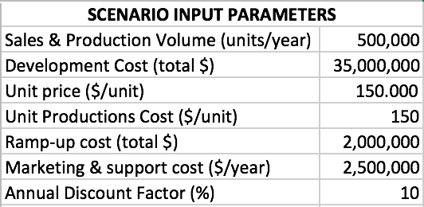

**NPV analysis**

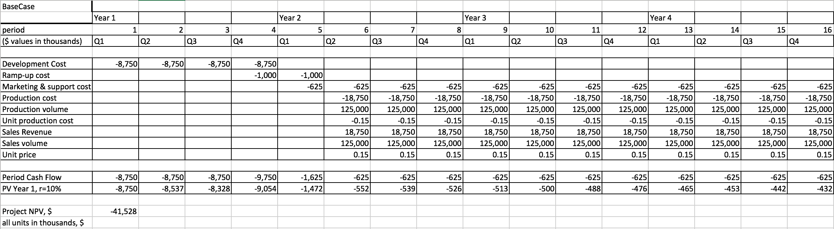

* 1. Minimum value that results in a positive NPV by the end of year 4.

**Scenario Parameters**

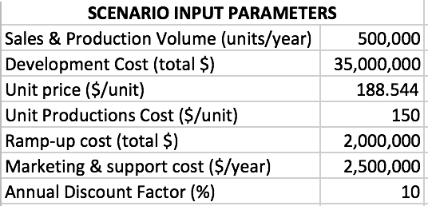

**Four Year NPV**

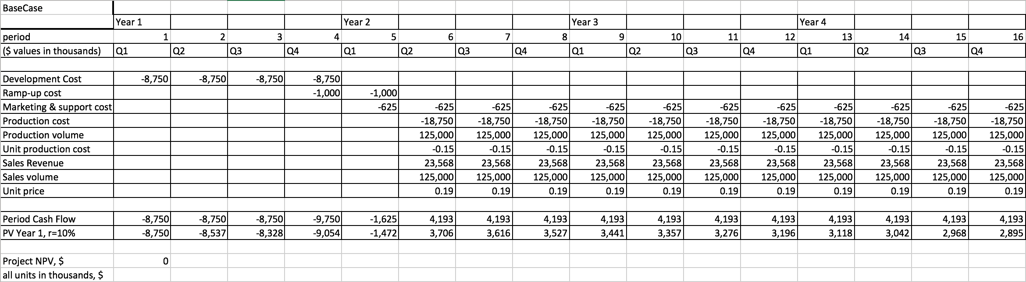

* As you can see above, the minimum value of the unit sales price for the product that results in a positive NPV by the end of year 4 is $188.544.
  1. Unit Sales Price Sensitivity Analysis and Trade-off law.

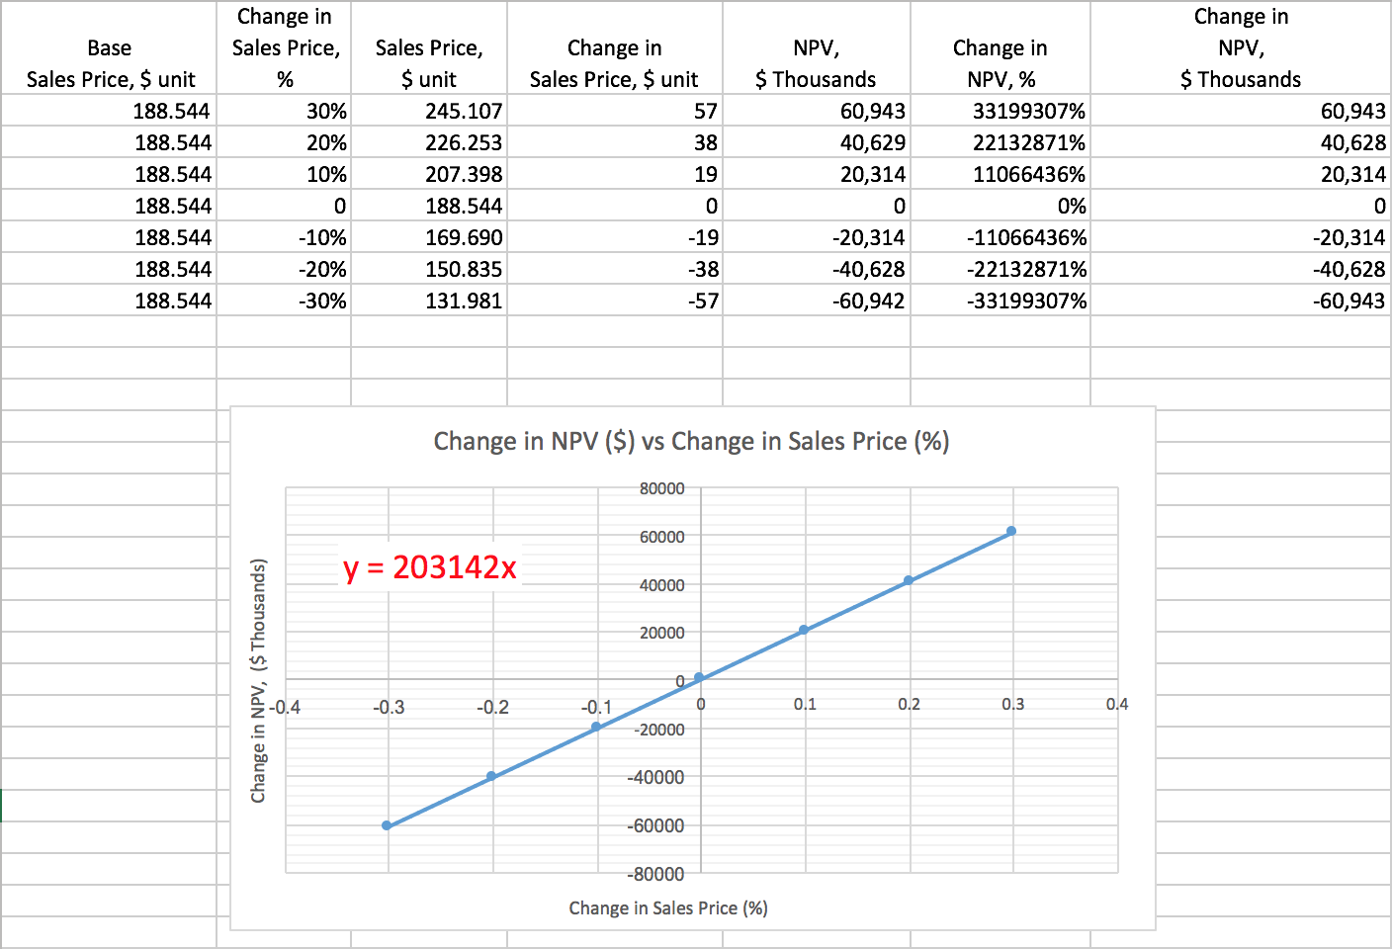

* The above figure is the sensitivity analysis of the unit sale price. The chart shows that the trade-off law is: For each 10% (x-axis value) increase in Unit Sales Price, there is $203,142K increase in NPV.
  1. I would recommend the software giant to sell their product at $499.99 per unit. This gives them an NPV of $355,560,000 for four years. I recommend this price because it is cheaper than the Oculus Rift but more expensive than the PlayStation VR. This gives them a competitive price even though it’s more expensive than the PlayStation VR. However, the reason for this is because their VR is supposed to be more advanced and of higher quality than Sony’s.
  2. The expected NPV based on my recommendation is $355,560,000 million. The figures below shows the results from the recommended price.

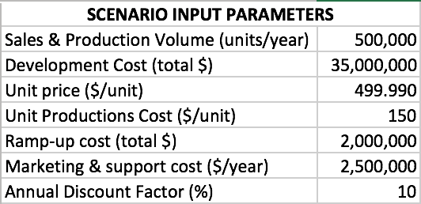

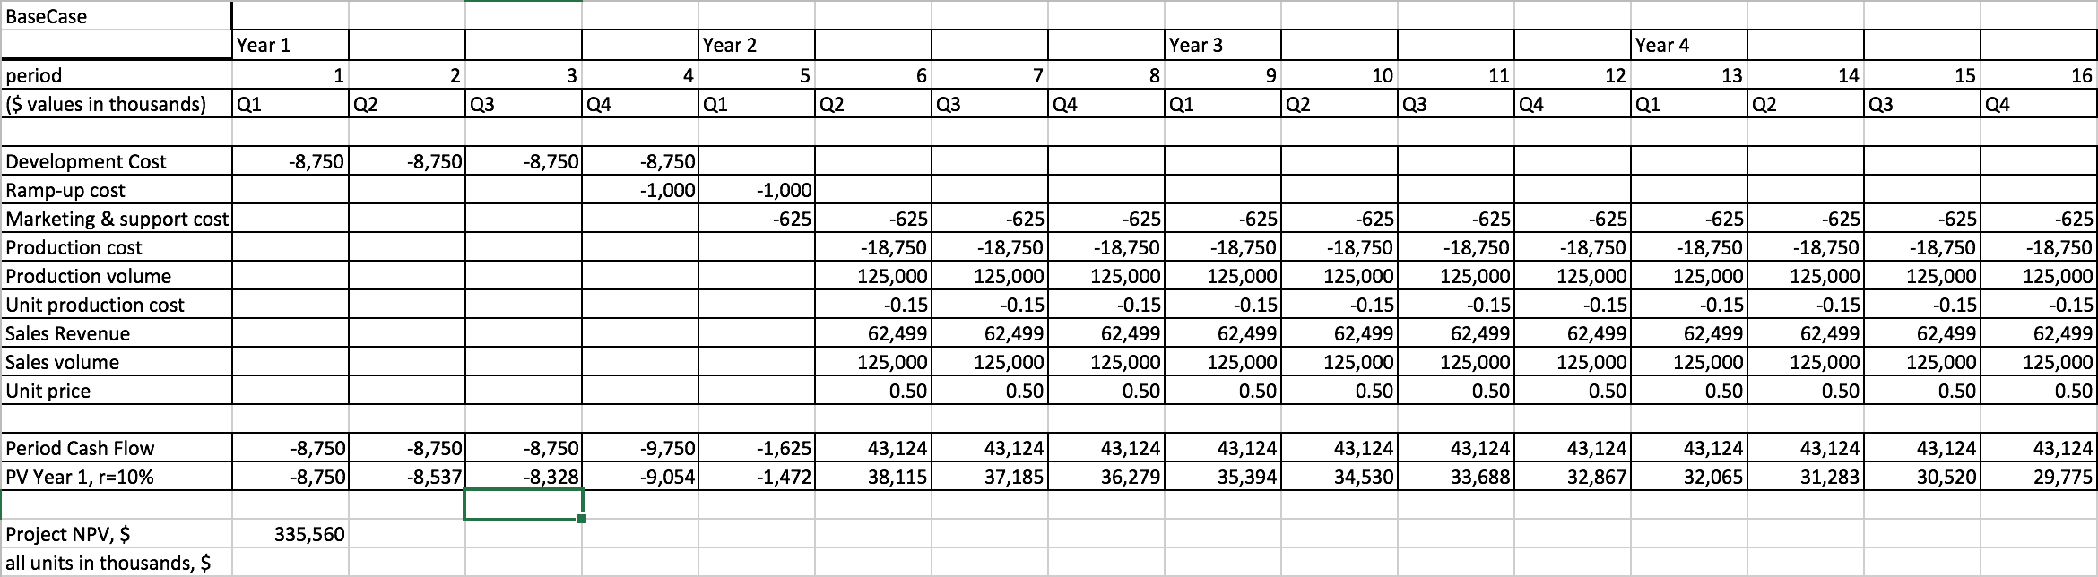

1. **Check Your Work**
   1. I used the numbers and schedule provided for the problem to create the 4 year NPV analysis for the VR entertainment system. I believe that my calculations were correct and that my solutions were reasonable. My end decisions were based on online research and comparisons to other companies.
2. **Learn and Generalize**
   1. I decided to advise the company to sell their device at a price between two competitors. This gave them the advantage of selling a device for the people stuck in the middle of buying something too expensive or too cheap (in terms of technical specifications). By creating a sensitivity analysis I was able see how the change in sales price would affect the NPV. This also gave me a rough idea on what I wanted to decide on for the final unit price.

**Problem 4: Information Technology for Product Design and Development**

1. **Define the Problem**
   1. We need to develop an information technology (IT) system to support the design and development of the proposed Virtual Reality (VR) entertainment system.
2. **Create a Plan**
   1. Develop my own product design and development framework, based on the appropriate modification of the MDC framework.
   2. Design an information technology (IT) system to automate and integrate the steps and stages in my framework.
3. **Execute**
   1. My framework will include the following steps based on the MDC framework given in class.

**Management (M)**: Perform steps 1-5 concurrently.

1. (Firm-level Strategy). Map the VR industry-market landscape for the technology/product, and then establish the overall competitive strategy, technology strategy, and market strategy of the technology firm. This will allow us to see what competitors are working on and how we may compete against them.
2. (Business Goals). Establish the business goals and objectives (ROI, %market share, revenue, and growth aspirations). These business goals need to be clearly related to the (clearly stated) vision and mission of the technology firm (also see Steps 4, 17). This will allow us to know what we want to accomplish with the development of the VR entertainment system.
3. (Developmental Goals). Define the overall development goals to align business goals, competitive strategy, technology strategy, and market strategy.
4. (Functional Maps). Create functional maps (time-based evolutionary maps) for engineering, manufacturing, and marketing in order to rationally decide which technologies and products to develop. A revenue map based on product/market segmentation is crucial for the selection of the appropriate target markets (also see Steps 2, 6, 13, 17). Functional maps of our proposed product can help us see how it has changed throughout the years. This can give us an idea on what we want to add or how to improve the product.
5. (Aggregate Project Plan). Use probabilistic decision analysis to develop an initial aggregate project plan, which is the mix of products to be developed (also see Steps 13, 17):

* Research & advanced development
* Breakthrough
* Platform
* Incremental (Enhancements, derivatives, hybrids)
* Alliance, or partnered projects

1. (Project Planning). Establish a cross-functional team for each technology/product development project. Develop a project plan using the design/development structure matrix, GANTT, PERT, and CPM charts.

**Development (D)**: To develop each product, **concurrently engineer** (CE) steps 9-13.

1. (Quality Function Deployment). Develop a comprehensive House of Quality (HOQ) to correlate customer needs to technical metrics and specifications.
2. (Reverse Engineering). Dissect existing products which are similar to the proposed new product using the Function Analysis Systems Technique (FAST).
3. (Conceptual Design). Create a function structure (FS) for your product, and use this FS to generate a morphological matrix (MM). Use the MM to generate several design concepts. Select one (or more) concepts using a utility function, which is based on an appropriate set of weighted selection criteria.
4. (Prototyping Strategy). Develop an appropriate prototyping strategy (physical vs. analytical; focused vs. comprehensive). Build and test proof-of concept and other appropriate prototypes based on the prototyping strategy.
5. (Product Architecture/Product Strategy). Establish the technology platform and product platform. Define the appropriate product lines to serve the target market segments (also see Steps 4, 6, 17). Look at who uses current consoles and people who are interested in 3D design. These can be possible markets to expand upon.
6. (Detailed design). Develop the detailed embodiment design of the product. Create sketches of each part and label what they do.
7. (FMEA).Perform a failure modes and effects analysis (FMEA) of the detailed design. Analyze the key components of the product and check for failure modes.

**Commercialization (C)** (Steps 13-16, above, are the transitions from D to C).

1. (Financial Model). Develop a base-case (nominal) Net Present Value (NPV) financial model in order to determine the expected profits (payoffs) from the product development projects. The NPV analysis models the appropriate cash-flows (sales revenues, development, production, marketing, and other relevant costs). Perform sensitivity analyses on the base-case financial model in order to understand and quantify trade-offs between time, cost, and quality (also see Steps 2, 4, 6, 13).
2. (Robust Design). Design the product for performance and robustness using “Design of Experiments”. Test the product for bugs and cross reference the FMEA.
3. (Product Release Map). Create the product release roadmap (closely related to Step 13).
4. (Supply Chain Management). Design the supply chain and distribution network for your product (addressed in MOT II: Supply Chain Management)

**MDC Framework Changes.**

I modified the MDC to work better with the design of the VR entertainment system. I decided to remove the High-Level HOQ step because we are already creating an HOQ in the development phase. I thought that having it in both places was redundant and that the first one wasn’t needed in phase. I think it’s better to have the company focus on their strategy, goals, and functional maps before working on the HOQ. Once they have a solid plan for their APP and project plan, then they can develop a comprehensive HOQ to correlate customer needs and technical specifications. I also removed the DFX because I believe the FMEA already covers what problems the product may have. By having a thorough FMEA we can eliminate the possibilities of major issues. Lastly, I removed the development funnel to save time and money. I believe the APP and project planning will be enough to produce a well-designed development process.

* 1. **Integrating the framework**

|  |  |
| --- | --- |
| **Step** | **Automation** |
| Business Goals | The business goals in the first phase can be organized into an excel doc. We can use the excel to graph each of the values. For example, ROI, %market share, revenue, and growth aspirations. By formatting the excel to take these values we can better see and understand what they mean and represent. |
| Prototyping Strategy | The prototyping strategy can be done with the Sketchup program which allows 3D modeling. By using this program multiple people can see what is happening and have access to the prototype images. |
| Financial Model | The company can use excel to create the financial model and NPV. By having a structured basecase in excel they can reuse the worksheet to save time and still have accurate results. |
| Project Planning | The company can use Microsoft project in order to create their project plan. It has the capabilities of making all of the needed charts and keeping they organized. By using Microsoft charts the company can have all of their project plan on one program. |
| Product Release Map | The company can create this on excel. This will make the roadmap easier to visualize and create. They can mark how long it will tank and when they want to have specific releases. By using excel they can also add in financial statistics to see how the product release map would fair over the set course. |

* The above chart contains methods for carrying out certain steps from the MDC framework that I created in step a).

1. **Check Your Work**
   1. I believe that my work is correct because I pulled the information from the given MDC framework. I also used my knowledge from class in order to make changes and improve it for the specific company. Overall, I believe that my solutions are reasonable.
2. **Learn and Generalize**
   1. I learned how to create an MDC framework and that it can be modified for certain products/companies. The MDC speeds up the overall development process and creates a uniform team. This in turn increases the quality of the end product and reduces miscommunication between workers.

**Problem 5: Conclusion**

1. **Define the Problem**
   1. Talk about the key lessons that you learned in this course.
2. **Create a Plan**
   1. Create a table with the key lessons you learned and examples.
3. **Execute**
   1. Table of Key Lessons

|  |  |
| --- | --- |
| **Key Lessons** | **Examples** |
| Structured Problem Solving | In this class I learned how to apply and create the structured problem solving method. This has allowed me apply and organized framework to anything that I’m working on. As a result, my overall performance and organizational skills have gone up. I believe that I will be able to use SPS in the future to increase the quality of my work. In this class we used the SPS on all of our homework problems and tests. |
| Project Planning | In this class I learned how to create a project plan. Creating a project plan allows me to create an organized schedule on when I want to complete certain tasks. This has made me better at meeting deadlines. By creating the project plan I’m able to see what I have done and what I still need to do. For example, for the final in this class we used project planning to plan out the order of our problems. Doing this allowed me to finish on time and eliminated the stress from not know what I had left. |
| Team Work | This class has greatly increased my teamwork skills. Prior to taking this class I hated working in groups as I thought that it only slowed me down. I didn’t like relying on other people to get work done as it could affect my own grade. However, in this class we were forced to work with a group on a project for the whole quarter. At first I was skeptical but as the quarter progressed I learned how to manage working in a team. I learned that having an affective team can increase overall efficiency and quality of whatever is being worked on. For example, throughout the quarter we worked in groups to develop and design a product. By working with my team and putting our energy together we created high-quality work. We did more work than could have been done alone. In other words, I learned that communication and teamwork is the key to success in Information Technology. |

* The above table shows the top three key lessons that I learned in TIM 105.

1. **Check Your Work**
   1. I believe that my work is correct and that the key lessons that I learned were valuable. I checked my work by proofreading and looking back through notes.
2. **Learn and Generalize**
   1. I structured my top three key lessons that I learned from this class into a table above. I believe that this class has strengthened my understanding and knowledge of IT. I can now create a structured and organized project plan for any product.